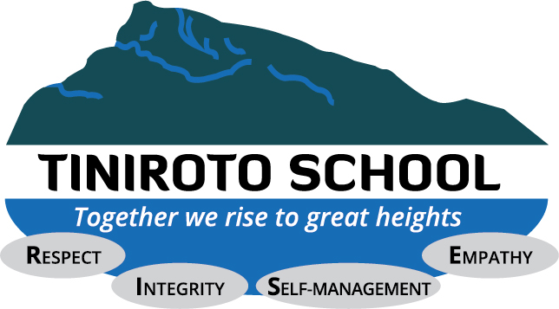
Long Term Plan by Reading Level/Age
Term 3, 2014
When students move up, we move their name into the appropriate box and date it.
Pink |  | PINK:  - Can read my own name  - Can hold the book carefully  - Can show you the front and back cover  - Know that writing carries a message that is shared  - Can show you what a word is, and what a picture is  - Can name some letters (capitals and lower case)  - Can talk about stories and use pictures to support  - Find the title  - Turn pages carefully  - Can read from left to right  - Say what I think might happen and why
RED:
- Can find and tell you the title
- Can point to every word I read
- Read lots of everyday words
- Read like I am telling a story
- Can go back and make it sound and look right
- Can predict what a word might be
- Know what a letter is
- Know what a word is
- Know that there are spaces after every word
Can say what I think about stories and poems
Red
Yellow |  | YELLOW:  - I Don’t need to finger point any more!  - Use punctuation to help me read clearly  - Can use the pictures, the letter-sounds and the sentence to help me understand  - Can solve new words by using what I know about other words, e.g. look – took  - Search for information in a book to predict, check and try new words  - Notice how some books are the same, and others are different  - Predict what I think might happen, or what the book might be about, and say why  - Notice compound words  - Use what I know about blends and ends to help me read new words
Blue |  | BLUE:  - Can self-correct when it doesn’t sound or look right  - Re-read to make it clear  - Think about the meaning and the look of the word when I tackle a new word  - Use what I know about word endings to read new words  - Use what I know about words to work out other words  - Read fiction and non-fiction, and know the difference  - Discuss the book clearly and give full answers to questions
Green |  | GREEN:  - Can read aloud and sound like I’m telling a story  - Read fluently and use the punctuation to help me  - Solve new words while thinking about the meaning, the spelling patterns and the sentence  - Read lots of different types of texts  - Discuss the character and plot and show why I think what I think!
Orange |  | ORANGE:  - Don’t need the illustrations as much and can start reading a text without using them  - Read longer sentences  - Use punctuation to guide my reading  - Think about the meaning, the sentences, the words and the pictures to help me understand as I read  - Search for and use syllables I know within words to read longer words  - Can read between the lines to think about other messages that may be hidden
Turquoise |  | TURQUOISE:  - Find meaning in the text while reading without needing to use the illustrations  - Can read lots of different types of texts and talk about how they are the same and different, and what their purpose is  - Use punctuation and text layout to read with expression  - Can read and understand long sentence structures and paragraphs  - Tackle difficult words using what I know about words (word families, word endings)
Purple |  | PURPLE:  - Use punctuation to keep track of longer sentences  - Can talk about what writers have done to make the story interesting  - Use what I know about fiction and non-fiction texts to predict what might happen, or what information I may find out  - Can use lots of different strategies and work out new words by looking at the sentence and thinking about the content  - Am learning to read silently or very quietly, keeping a good pace
Gold |  | GOLD:  - Can predict content, layout and story development of lots of different books  - Read silently or quietly  - Solve most unfamiliar words as I read - using different strategies  - Can read and talk about fiction, non-fiction or poetic language  - Notice what writers do to create meaning
8.5-9 years  2A |  | - Can read aloud confidently using expression  - Can talk about the ways the book is written or presented  - Can suggest how the book could end differently, or how the plot could change  - Can identify and discuss main characters, their actions, and their feelings  - Can use what I know about the alphabet to find information in dictionaries and indexes  - Can talk about how the story could be changed  - Can read silently  - Search for and find information in texts more flexibly  - Notice the spelling of unfamiliar words and relate to known word  Express opinions about what I read and discuss my interpretation of text
9-10 years  3B |  | 9-10 Years:  - Read by myself, using different strategies to help me understand  - Can show understanding of main points  - Can talk about the texts I like and dislike, and why this is  - Can find and use information from non-fiction texts  - Can make sensible predictions and use the text to back them up  - Can use appropriate voices for characters  - Can adopt a story-telling voice  - Can recognise the main differences between fiction and non-fiction texts
10-11 years  3P |  | 10-11 YEARS:  - Can read a range of appropriate texts fluently and accurately  - Can justify my prediction by referring to the story  - Can begin to find meanings beyond the literal  - Can respond to the tension in a story  - Can read ahead to determine direction in meaning  - Can pause appropriately in response to punctuation and/or meaning
11-12 years  3A |  | 11-12 YEARS:  - Show understanding of big ideas, themes, events and characters  - Can identify key points when reading an appropriate text  - Can use evidence from the text to justify opinion  - Can locate and use information  - Can show with help that I have used inference and deduction  - Can find relevant words in a text without prompting  - Show awareness of the listener through use of pauses, emphasis and pace  - Can understand how the meaning of sentences are shaped by punctuation, word order or connectives
12-12.5  4B |  | 12-12.5 YEARS:  - Can refer to the text to support predictions and opinions  - Can show by my answers that I have read beyond the literal and can use inference  - Can tackle unfamiliar and challenging texts with confidence  - Can identify expressive, figurative and descriptive language used to create effect  - Can use skimming, scanning and note-making to identify the gist or key points in a text  - Can recognise the ways writers present issues and points of view in fiction or non-fiction  - Can identify how language is used and structured in a range of texts  - Can recognise compound and complex sentences and tell you the difference  - Can recognise and identify the language conventions of a range of texts  Can identify fact and opinion in a text
12.5-13 years  4P |  | 12.5-13 YEARS:  - Can select relevant information from a range of suitable texts  - Can identify key features, themes and characters across a range of appropriate texts  - Can select sentences, phrases and relevant information to justify opinions  - Clearly understand the story and show this by answering a range of questions about the text  - Can use detail to give persuasive answers to questions  - Can explain implied meanings by using examples from the text  - Can use note-making effectively to summarise the main points in a text
13-14 years  4A-5B |  | 13-14 YEARS:  - Can use inference and deduction with confidence  - Can describe and evaluate authors’ use of techniques, e.g. narrative structure, themes or figurative language, justifying interpretations using the text  - Can retrieve and collate information from a range of sources  - Can communicate a sense of the hidden irony  - Read and comprehend text that is abstract and removed from personal experience  - Make critical comparisons between texts  - Can recognise and discuss the elements and purposes of different text structures, e.g. reports, procedures, narratives etc.

