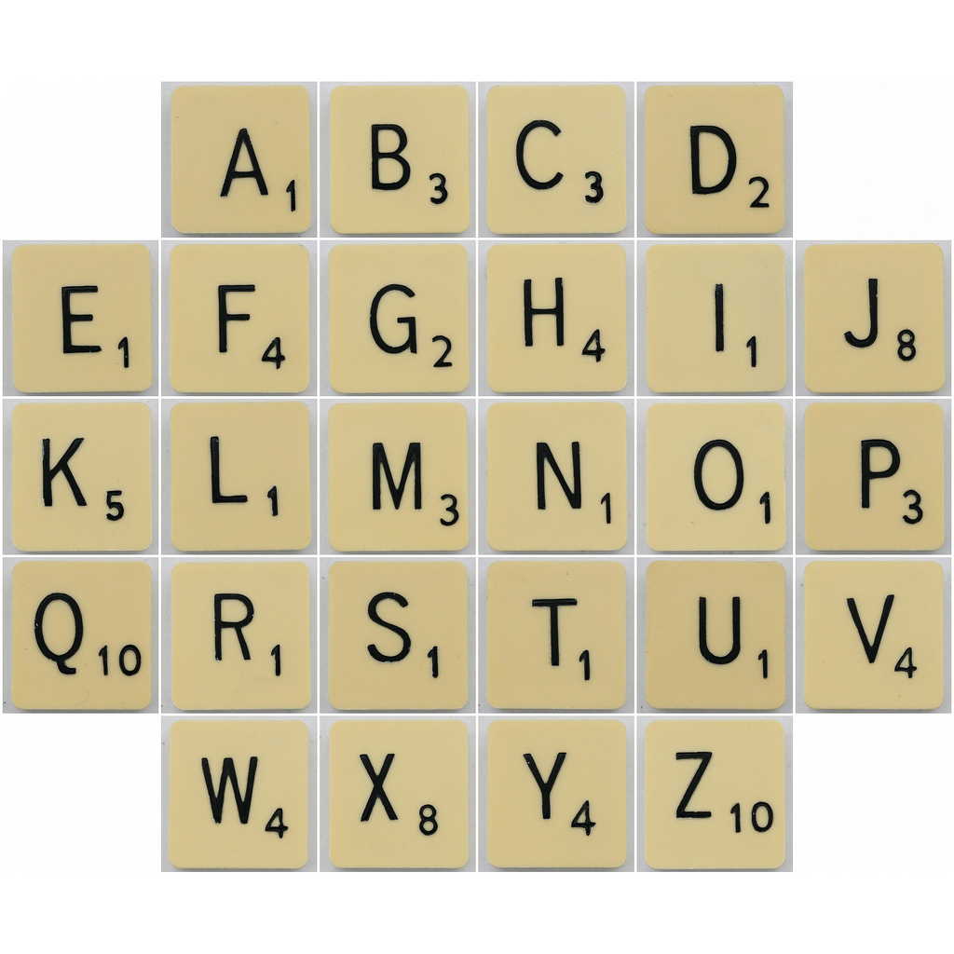
How many points would you get for each of your spelling words??
If my spelling word was CAT it would be worth 5 points.
C = 3 A=1 T=1 3+1+1=5

