Using a kiwidex game to teach non movement concepts and then game strategies.
Session 1 - Tunnel and Chase Kiwidex Page 134 – 135
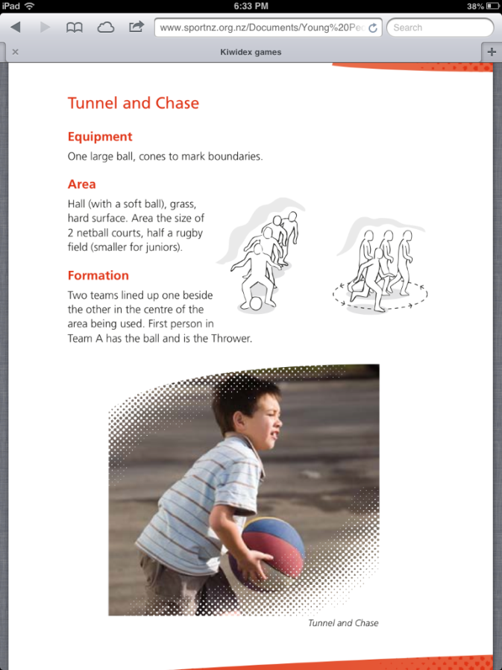 | 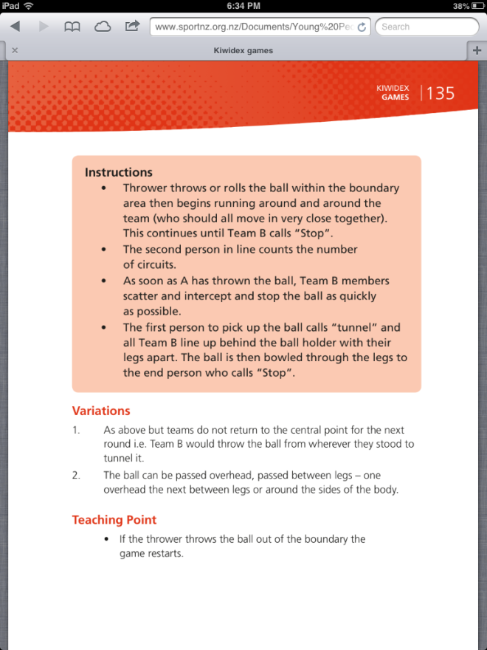

Play as described but use a rubber chicken or other novelty item. It is also good to allow the game to go for a number of rounds (Call the game Chuck the Chicken)
A task card for this game can be found at the link below. You can also view an animated walk through here too.
http://www.opheaprograms.net/playsport/en/activitydetailscdd7.html?ActivityId=23
Discuss - taking turns as the thrower or runner, wasting time by arguing, being selfish, placement of throw, impact of pressure on decision making and technique (connects to previous lessons)

2nd session - Over a net
Play the same game but this time put each team on a court where the throw must go over a net and land in the court. If thrown out other team gets a point. A point is also scored if the ball bounces twice on the ground
Discuss:
Which way is best to form your line? Parallel or perpendicular to the net
What if you catch it on the full? (suggestion: no need to form the line JUST THROW IT BACK= less time for the other team to score?)
How do you cover space? When do you need to be aware?
Could teams leave a player out of the “huddle” to prepare to catch the throw
Where do you choose to aim your throw? What other sports score this way?
3rd session - 2 bounce
Play 1 v 1 or 2 v 2 (catch and throw) where the aim is to make the ball bounce twice on the other side of the net.
Change the court size and dimensions.
Add double point zones by placing a spot marker on the court to encourage defending one area (creating scoring possibilities elsewhere)
Try playing with large ball (catch and throw) or a bouncy ball (pat or push)
A similar task card can be found at:
http://www.opheaprograms.net/playsport/en/activitydetails0319.html?ActivityId=37

4th session - 3 Pass and Run
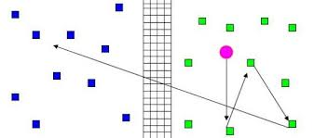
(6 V 6) over a net on a court about the size of a netball third.
One team must pass 3 times and then throw the ball over the net.
Once the ball is thrown over the net the team must run to the back of the court (or further – place a cone off the court) and back to get ready to receive the return.
A point is scored when the ball bounces twice.
Discuss
Systems to cover space
Systems to make the running less exhausting
Communication needed
Creating space and uncertainty by passing

