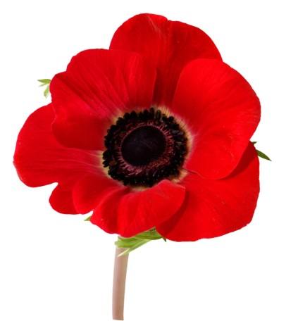
Poppy Poppy

Poppy poppy what do you say?
Wear me on ANZAC Day.

Poppy poppy what do you tell?
Many soldiers in battle fell.

Poppy poppy what should we know?
Peace on Earth should grow grow grow!

