Playdough Recipe!
You need:
- 2 cups plain flour
- 2 tablespoons vegetable oil
- 1/2 cup salt
- 2 tablespoons cream of tartar
- Up to 1.5 cups boiling water (adding in increments until it feels just right)
- food colouring
- few drops glycerine (optional- adds more shine!) – I didn’t use though
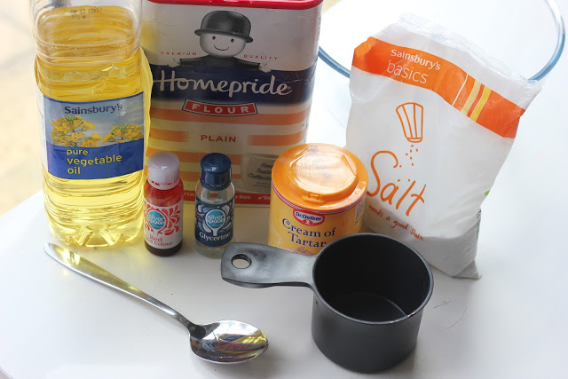
Method:
- Mix the flour, salt, cream of tartar and oil in a large mixing bowl
- Add food colouring TO the boiling water then into the dry ingredients
- Stir continuously until it becomes a sticky, combined dough
- Add the glycerine (optional)
- Allow it to cool down a little then take it out of the bowl and knead it vigorously for a couple of minutes until all of the stickiness has gone. * This is the most important part of the process, so keep at it until it’s the perfect consistency!*
- (If it remains a little sticky then add a touch more flour until just right)
You can store this in an airtight container (I just use standard plastic lunchbox containers) for up to a year (depending on how gross it gets!). For a whole class – 25-30 kids - I last made 6 x the recipe, double lots in green, pink and yellow. I also added peppermint essence which smelt really nice! Enjoy!

