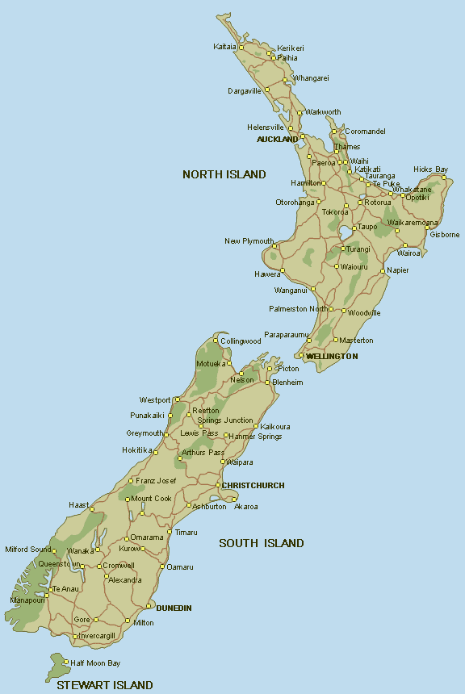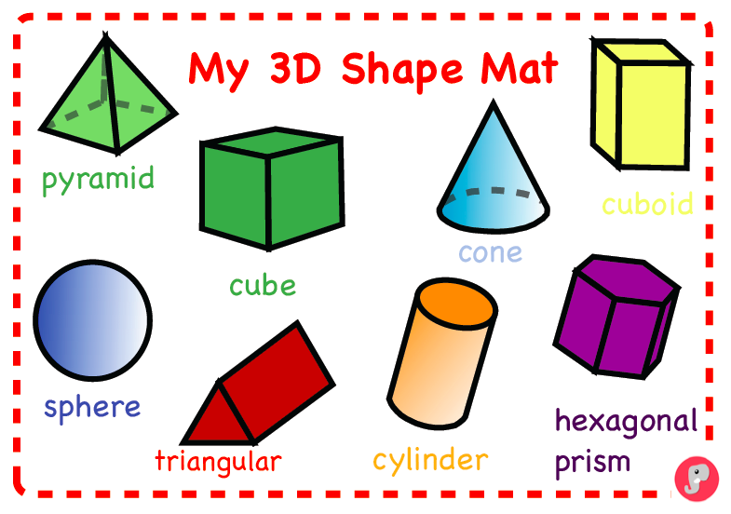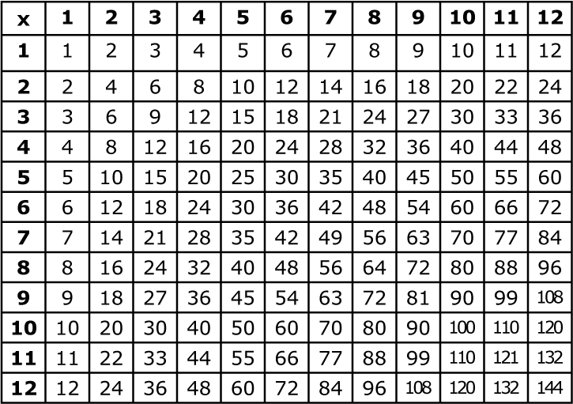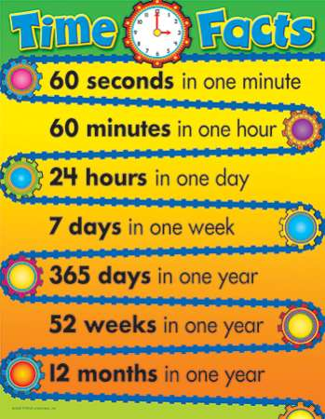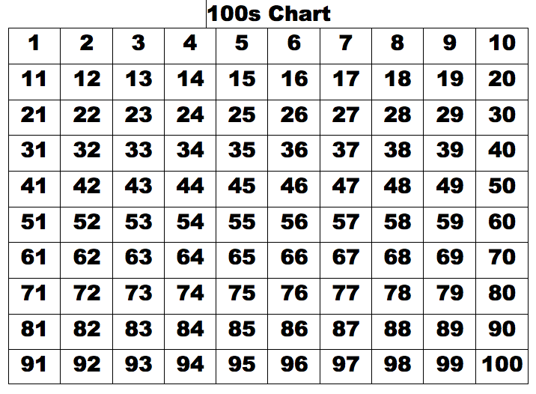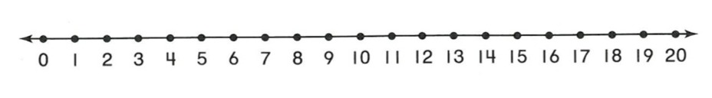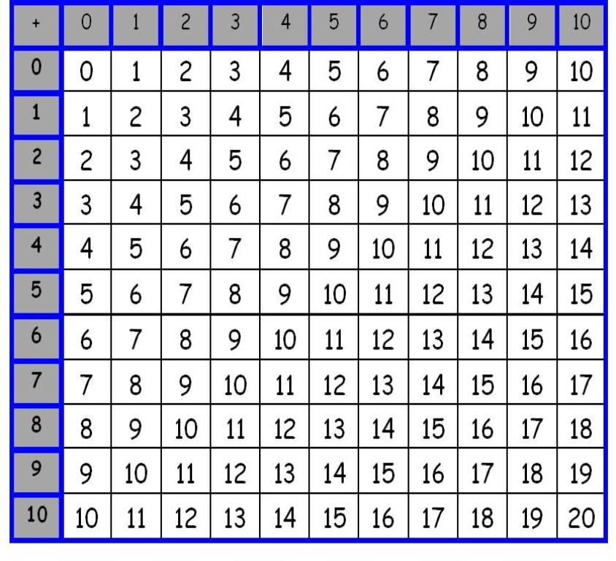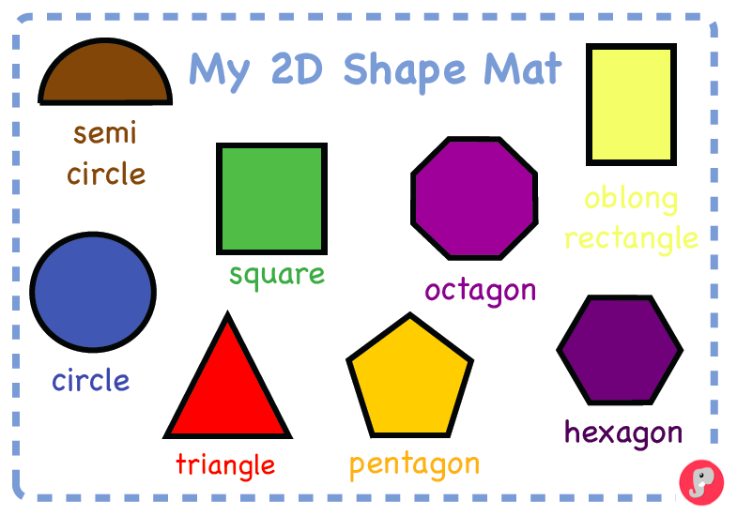

Ten, twenty, thirty, forty, fifty, sixty, seventy, eighty, ninety, hundred

New Zealand, Canvastown, Havelock, Rai Valley, Linkwater, Blenheim, Nelson, Pelorus, Wakamarina, Waitaria Bay

Sunday, Monday, Tuesday, Wednesday, Thursday, Friday, Saturday