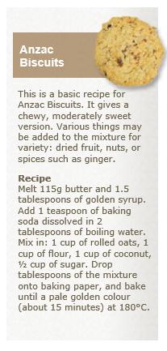 | Anzac Biscuits  New Zealand and Australia share a tradition of Anzac Biscuits. Both countries claim to have invented them, but Anzac Biscuits are similar to many other older biscuit recipes that are designed to produce crisp, hard and nutritious biscuits that keep well. The earliest known recipe for Anzac Biscuits appears the 8th edition of the St Andrew's Cookery Book, published in Dunedin in 1919, two years before the earliest known Australian recipe was published.  One of the food items that women in both countries sent to soldiers during the First World War was a hard, long-keeping biscuit that could survive the journey by sea, and still remain edible. These were known as Soldiers' Biscuits, but after the Gallipoli landings in 1915, they became known as Anzac Biscuits. Soldiers themselves may have made a similar form of biscuit from ingredients they had on hand: water, sugar, rolled oats and flour.  The traditional Anzac Biscuit is hard and flat - ideal for dunking in tea and then eating. During the First World War, some soldiers used broken biscuits to make a form of porridge to add some variety to their diet.  Over the years, softer and chewier versions of the biscuit have appeared. There are many recipes for Anzac Biscuits. Common to most is the inclusion of rolled oats, coconut, butter and golden syrup. Eggs almost never feature. This may be because eggs were in short supply during the First World War. Many varieties of biscuit do not have eggs, however, and like Anzac Biscuits rely instead on chemical rising agents such as bicarbonate of soda (baking soda).

