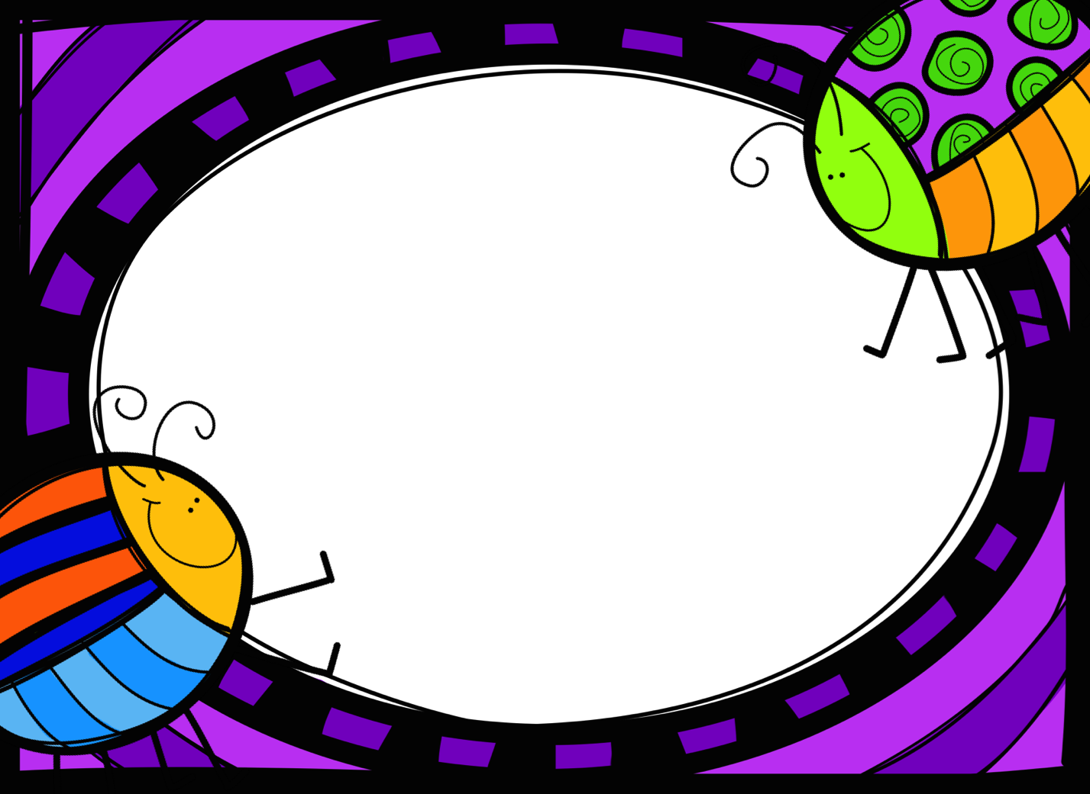

Noisy Class?
- bouncyballs.org
- Use a quiet voice yourself
- Quiet critters (see Pinterest)
- Too Noisy Pro (app) Silent Light (app)
- Play “Beat the teacher” – if someone is talking teacher gets a point, if class is quiet they get a point. Can team with a reward or consequence.
- Turn a rain maker up and down and kids adjust their volume until they can hear it.
- Have a LOT of brain breaks (gonoodle.com is awesome)
- Write NOISE on board. Rub out one letter starting with ‘E’ each time the noise level is too high. If they lose the whole word they stay in at break time. They can earn letters back if they are quiet.
- Play quiet music – classical or relaxing work well
- Class Dojo
- Caught being quiet charts
- Bring whole class back to the mat
- Use a “Noise-o-meter” (see Pinterest)
- Wear a special hat or headband while teaching guided sessions which means students can’t interrupt and must use quiet voices.

