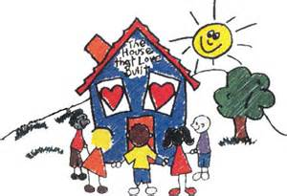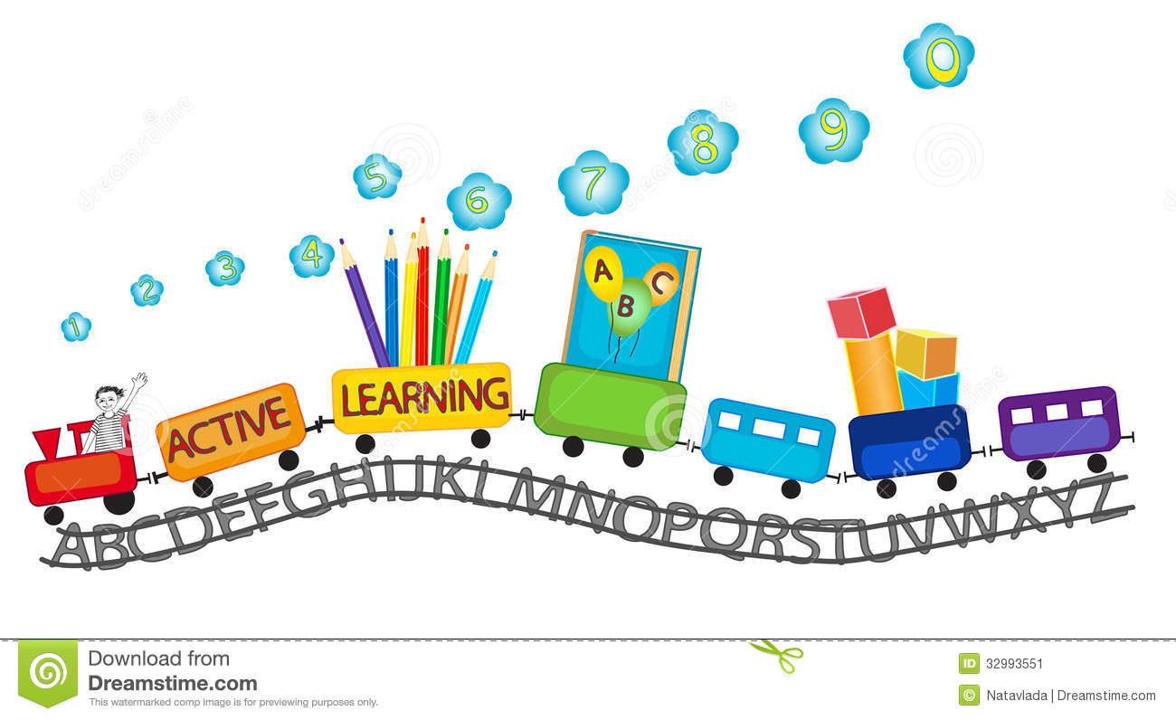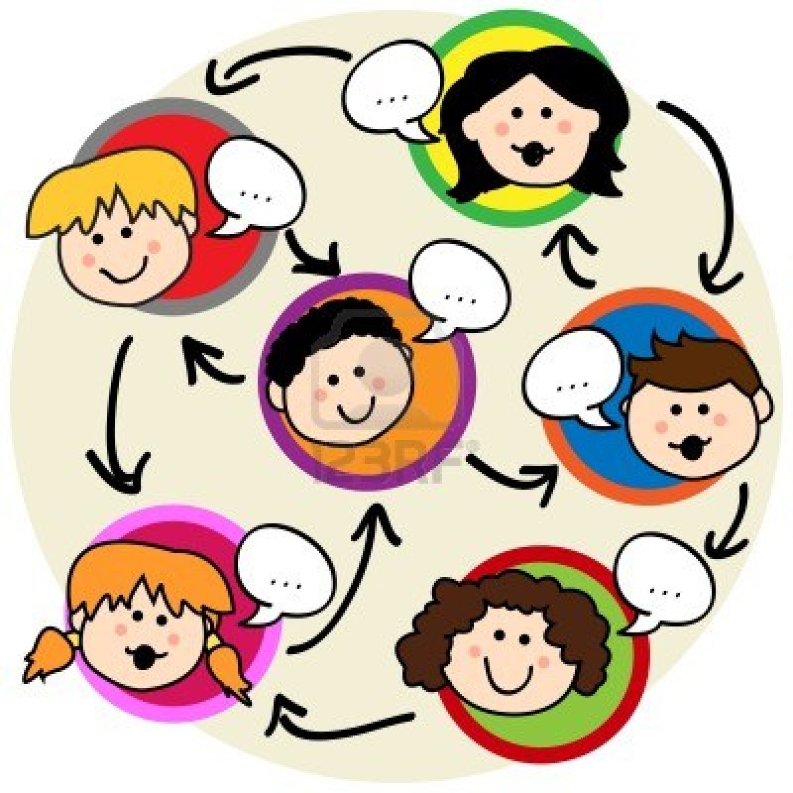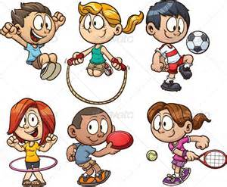

I put photos here

Name:

Date: 14/2/14

Teacher: Mrs Rebecca Bright

Teacher:

**NEW ENTRANT ASSESSMENT**

**LEARNING GOALS MEETING**

**DATE:**

**PRESENT:**

**IDENTIFIED GOALS FOR __________**

Welcome to. Over the last 4-6 weeks your child has been beginning their journey as a school learner. This is an exciting time for children, parents and teachers as we get to know you and your child and develop a learning relationship together.

**PARTICIPATING AND CONTRIBUTING**

**LISTENING SKILLS**

I can take turns to listen and speak

I can take turns to speak.

I can follow instructions

I can share after listening during buddy talking

I can retell a story

**Want some more fun ideas for learning?**

See your child’s teacher or share with them what is working for you. We can share that idea with others. Let’s all get on board together for learning success.

**PARTICIPATING AND CONTRIBUTING**

I join in with learning activities.

I need support to join in.

I can share with others.

I join in with games and sports.

I am willing to try new activities

**TAKING CARE OF MY PROPERTY**

I can take care of my own things.

I can follow the morning routine.

I need support to complete routines.

I can sit on the mat

I can stay with my group during learning

**You can support these skills at home by:**

* Talking to your child.
* Listening to your child.
* Encouraging your child to try new things.
* Supporting your child’s efforts in a positive way.
* Expecting your child to demonstrate positive behaviour.
* Encouraging your child to independently care for their property.

**ORAL LANGUAGE SKILLS**

I can communicate my needs and wants using language.

I can answer questions and ask questions.

I express myself using full sentences

I can share news with my class

I can

**Support Reading at home by:**

Reading for fun with your child at home.

Letting your child see you reading.

Completing school reading homework every day.

Practising key high frequency words every day.

Read poems every day.

Practising Alphabet learning every day.

**Support writing at home by:**

Encouraging children to write at home. Children can help to write letters or shopping lists.

Encouraging your child to recognise and write their name.

Completing practise activities from school

**LITERACY SKILLS**

**WRITING**

I attempt to write.

I can draw a picture plan with recognisable objects

I can say what I want to write

I write using marks.

I write using letters.

I can write words using letter sounds.

I can write use words I know to write a sentence independently.

**ALPHABET**

I can name the alphabet letters.

Upper case /26

Lower case /26

I can match the letters with their sounds /26

**MY NAME**

I can recognise my name.

I can write my name by copying over it.

I can write my name by copying.

I can write my name independently.

**READING**

I like to read.

I can point with 1-1 matching.

I can read keywords.

I can talk about what I read

I can read poems

I can follow the repeating pattern of a text

I can read text using word and sentence structure knowledge.

**GROSS MOTOR SKILLS**

**I can run with control over movement**

**I can jump/hop/skip**

**I can climb confidently on play equipment**

**I can follow simple dance moves**

**I can throw/catch/kick a large ball**

**FINE MOTOR SKILLS**

Pencil Grip

I can hold a pencil correctly.

I need help to hold my pencil correctly.

I can draw recognisable objects

Scissors

I can hold scissors correctly

I need support to use scissors.

I can cut out simple shapes independently.

I am learning to cut following the outline.

**Support Maths learning at home by;**

Counting household objects, how many pegs?

Playing counting games, what comes before after?

Giving children the chance to work out problems. How many plates do we need for dinner for everyone? What if Grandma is coming too? How many more?

**NUMERACY SKILLS**

I can count forwards to

I can count backwards from

I can count a group of objects up to

I can make a group of objects up to

I can name the numbers before and after up to

I can complete simple addition/subtraction problems

I can follow/make patterns with objects

I can name the basic shapes

I can name the primary/secondary colours

**MOTOR SKILLS**

**NUMERACY SKILLS**