My Writing goals | I can do it!

My Writing goals | I can do it!

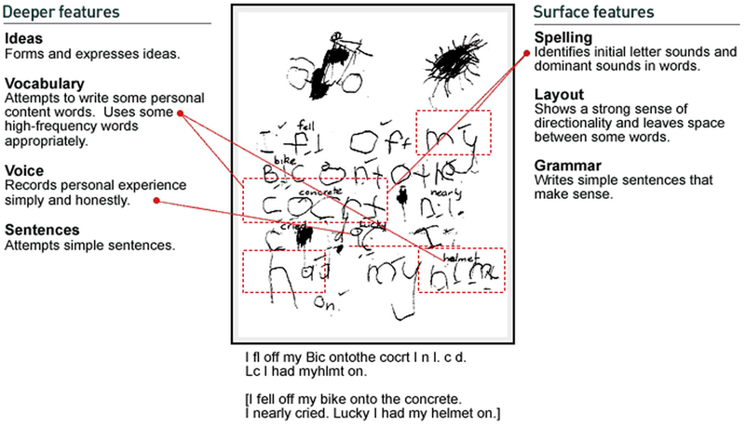

My Writing goals | I can do it!

My Writing goals | I can do it!

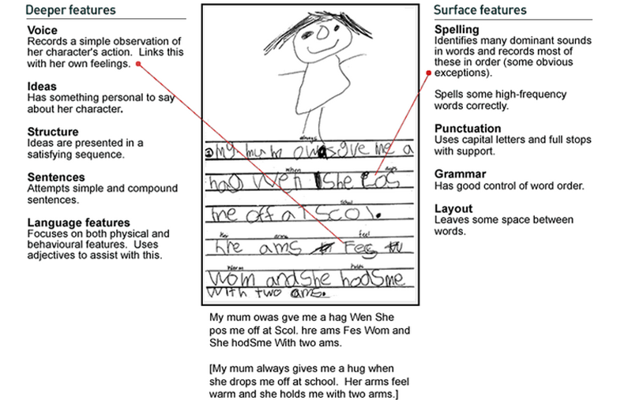
My Writing goals | I can do it!

My Writing goals | I can do it!

