**Could you explain that to me another way?**

**What I heard you say is . . .**

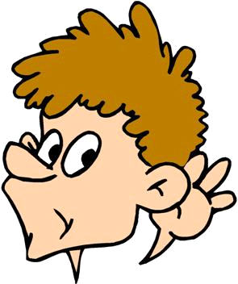

**Can you tell me more about when you . . .** 

**I have a question about**

**when you . . .**

**I did it this way . . .**

**I noticed that**

**you . . .**

**I disagree with that**

**because . . .**

**I agree with that because . . .**

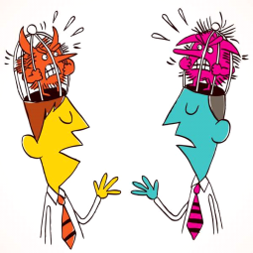





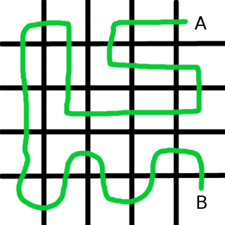

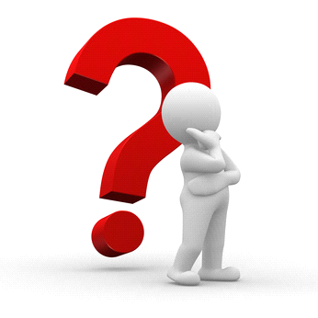



**I’m not sure if I understand yet. Can you help?** 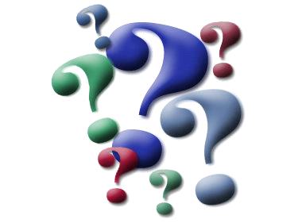

**Did you say that you . . .?**

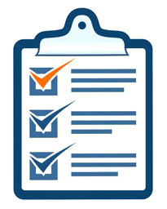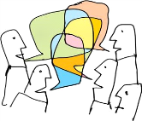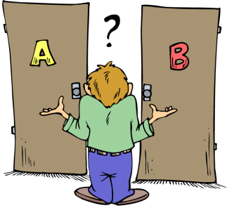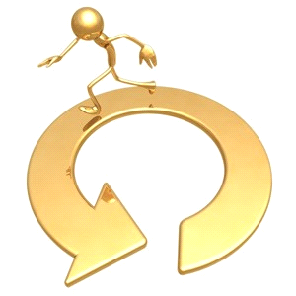

**I like how you . . .**

**What did you start with?**

**How did you know your answer was right? 👍☺★**

**How can we**

**check your**

**result?**

**Why did you choose that strategy?**

**Could I add on to what you**

**said?**