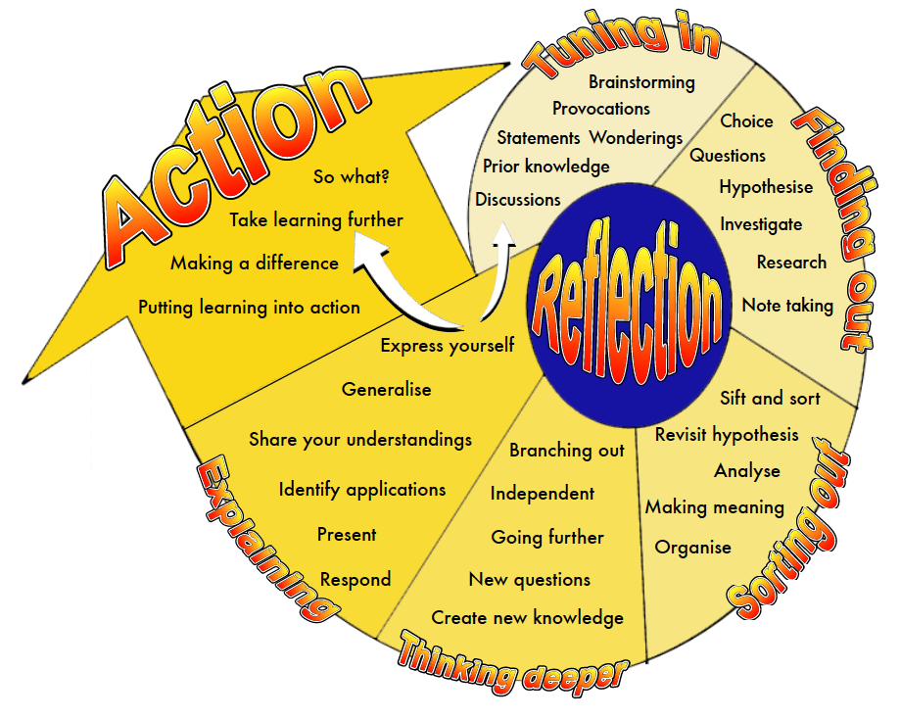

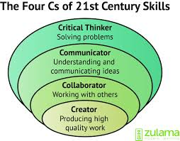

KANDINSKY
MATHEMATICS AND STATISTICS
INQUIRY

KANDINSKY
MATHEMATICS AND STATISTICS INQUIRY

LEVEL THREE LEVEL FOUR

http://www.art.com/gallery/id--a26/wassily-kandinsky-posters.htm
http://www.wassilykandinsky.net/

Day 1 | TUNIING IN | Give children the name on the board. What is this and what has it got to do with numeracy. | Critical thinking
Day 1 | FINDING OUT | Children research the ‘thing’ and record any information in the visual diary. | Communication  Critical thinking
Day 2 | SORITING OUT | Sort information – why are we looking at Kandinsky in Numeracy time. = the use of geometric shapes in his abstract art. | Communication  Critical thinking
Day 2 | FINDING OUT | Give children criteria for their art composition. Eg triangle; parallel lines; perpendicular lines; circle; irregular pentagon; rhombus; trapezium | Critical thinking  Communication
Day 3 | THINKING DEEPER | Use the geometric shapes to create a composition, using Kandinsky as a motivation piece. | Communication  Creator / innovation
Day 3 | EXPLAINING | With a buddy identify the ‘criteria’ in their art work.  Show T composition = T to check with | Collaboration  Communication
Day 3 | ACTION | Share with class and put on wall. | Communication

Level 1 | Shape = Sort objects by their appearance
Level 2 | Shape = Sort objects by their spatial features, with justification  Identify and describe the plane shapes found in objects
Level 3 | Shape = classify plane shapes and prisms their spatial features  Represent objects with drawings and models
Level 4 | Shape = identify classes of 2D and 3D shapes and geometric properties  Relate 3D model to 2D representations and vice versa.

Day 1 | TUNIING IN | Challenge to create a composition using  A compass.
Day 1 | FINDING OUT | What are five things we now know about circles  Key words – radius, diameter, arc, sector, circumference, pi,  What do we use to draw circles?
 | SORITING OUT | Teach children how to use a compass (drag, not push, spin the tip in your fingers, not move the paper)
 | FINDING OUT | Google images for circle art.
 | THINKING DEEPER EXPLAINING | Generate circle art, using a compass.
 | ACTION | Display on class wall.

