Home Learning Activities Term 1 – Senior Syndicate
Choose at least 5 of these activities to complete this term. We are looking for QUALITY projects.
Consider the most appropriate format to present your idea -e.g. poster, labelled diagram, model, photographic, collage, PowerPoint, creative story, movie, chart, online blog. (Some activities will be better suited to certain formats than others!)
Check with your teacher for when your classes projects are due
Design a LOGO and SLOGAN for your school community or your team community | 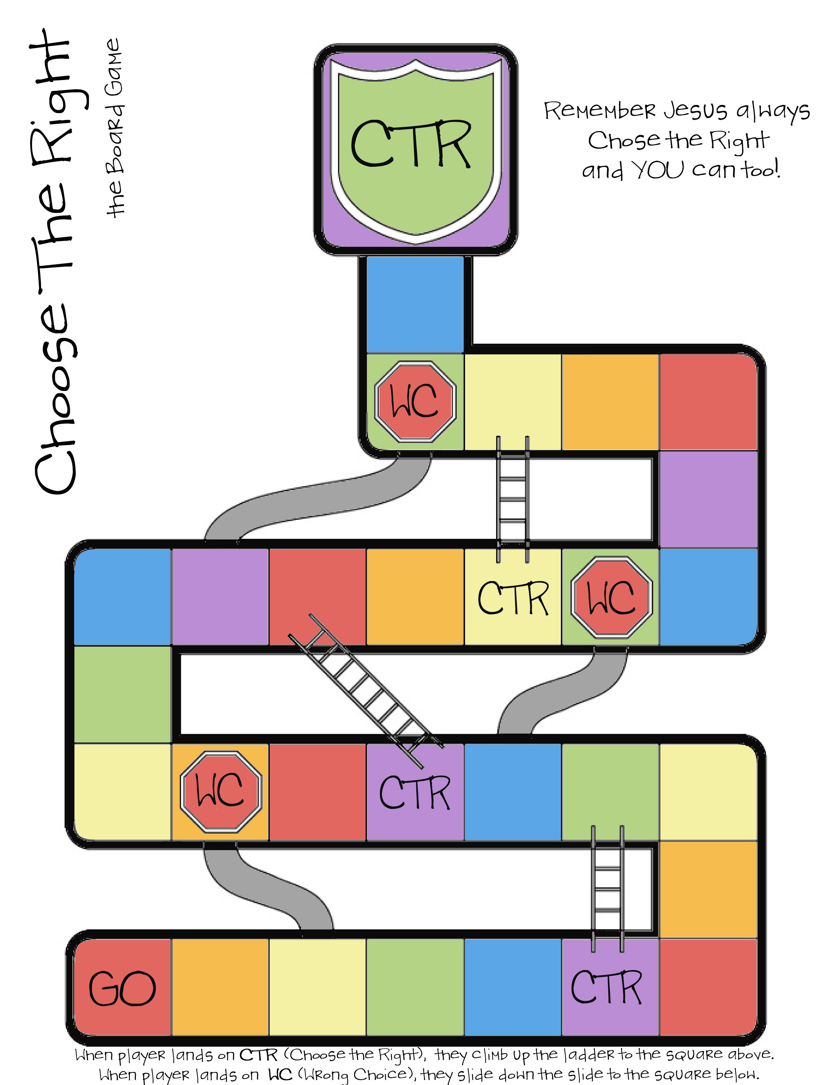  Create a board game that teaches us a bit about poverty or what it means to be part of a community | 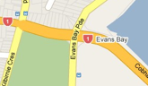  Design your PERFECT community – you could do this in map form or 3D model form | Pick an occupation that interests you – research what is required to do that job, what qualifications are needed etc | Choose a third world country – research about that place and comment on what it ‘might’ be like to live there – include flags, festivals, foods, money etc
Choose a charity and work out a way to raise some money for them – keep a diary of your progress | Build a model of Laingholm – or the place where you live out of JUNK! You might need to draw a plan/map first | Create a piece of music or a song/rap that represents a community of your choice – school, friends, family, Laingholm etc | Design your OWN community in a shoe box – must include buildings, recreation and transport access | 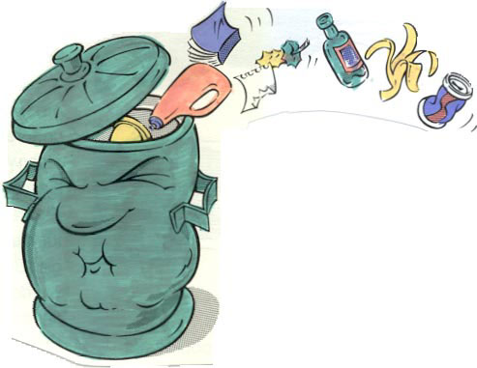  Create a PHOTO STORY of a weekend day in the life of your FAMILY COMMUNITY
Statistical investigation – count and collate all the recycled items from your household in a week – display your findings on a graph | Design a poster for having litterless lunches at school – it needs to be big, bold, simple and informative for students at school to understand | 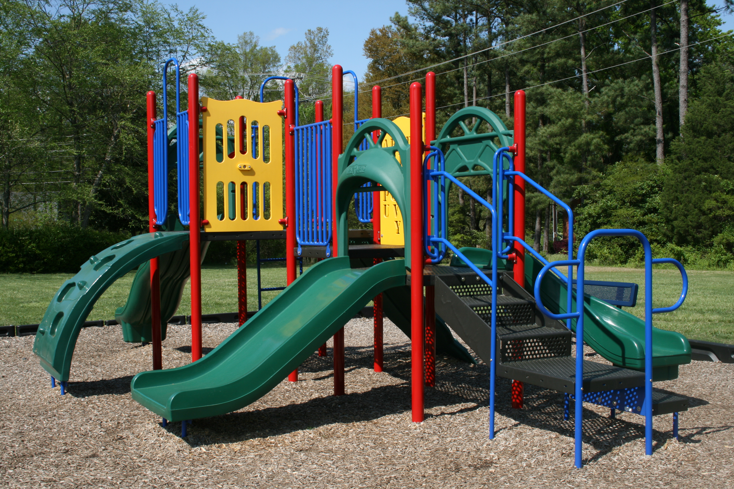  Design your perfect school playground – you could use mine craft to design it! | Plan and cook a meal for your family using only fruits and vegetables! | Design a machine or robot that will help your local community in some way
Thinkers Keys – create an A - Z of all the occupations you can think of | Create a wordsearch or crossword puzzle for your class mates to complete based on the Community of Laingholm School | Write a story or poem that describes belonging to a particular community – make it interesting enough to hold the readers attention | Write a letter to your teacher to tell them all about yourself and what you are good at, your interests and dreams | Student Choice!

