FUN MATHS – PLAN THE DREAM OVERSEAS SCHOOL TRIP FOR OUR CLASS!!!
Aim: Research and Design a dream holiday (anywhere in the world!) for you and your class mates. You can work with 1 other person on this project.
Budget: $2000 per student (plus spending money). *The school has been donated a large amount of money for student travel.
Background Research: 1. How many students are there in your class? 2. So that it is safe you will need 1 adult to supervise/look after 6 students. How many parents will need to come? (remember to include your teacher!) 3. Where does your class want to go? List 10 places in the world that you think your class would like to visit. Survey the class and choose the 2 most popular locations. 4. To help you plan the trip ask your classmates what they like doing on holiday. Keep this research to help you later when you are organising the activities. 5. Food: Are there any dietary requirements or food allergies in your class? Keep this research to help you later when you plan your menu.
Investigate: For each of your three most popular locations (chosen in your background research) investigate the following things…..
ACCOMODATION – Where will you stay? 1. Choose 5 options and compare the locations (use google maps to help you). Include the prices and types of accommodation. 2. How close is it to the airport? 3. Which is the best option for your class?
HOW WILL YOUR CLASS GET AROUND? 1. Will you use public transport or hire vans? Compare the prices and the practicality of each option.
WHAT WILL YOU EAT? – Design a menu 1. Include breakfast, lunch, dinner and snacks. 2. Are the dietary requirements or food allergies catered for? 3. Are the meals filling and include vegetables and fruit?
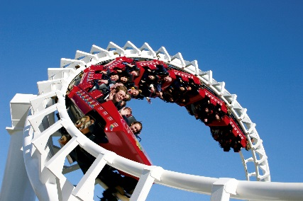
WHAT WILL YOU DO? 1. Remember to include activities that your class will enjoy. 2. Are the activities close to your accommodation?
DID YOUR TRIP COME UNDER BUDGET? 1. Is the trip under $2000 per student? - If it did that’s awesome! If it didn’t come under budget go back and make changes so that it is under budget.

Design the trip: - Put all the information that you have researched and investigated to design a detailed timetable for the class trip.
(Start this part when you have researched and designed a timetable for both of your options).
Feedback: 1. Design a PMI to go with both of your timetables 2. Ask 10 students in your class to look at the PMI and fill in the PMI
Reflect: 1. Look at the feedback from the PMI forms. Make any affordable changes from the feedback that they gave. 2. Decide which location/option is the best.
Present: 1. Your chosen idea to the class; include… - A detailed description of where the class is going - A detailed timetable of the trip - A detailed budget of the trip - Include images of the accommodation, activities etc
