Commands

Sit  E noho | Stand  E tū
Come here  Haere mai 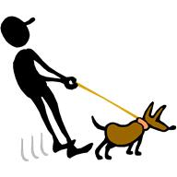 | Go away  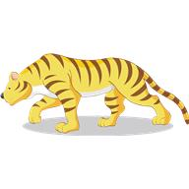Haere atu
Listen  Whakarongo | Look  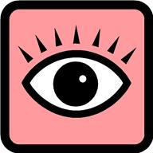 Titiro
Stop  Kāti | Wait  Taihoa

Days of the Week

Rāhina | Monday
Rātū | Tuesday
Rāapa | Wednesday
Rāpare | Thursday
Rāmere | Friday
Rāhoroi | Saturday
Rātapu | Sunday

Greetings

Kia ora. | Hello. Hi. Gidday.
Ata mārie | Good Morning
Ahiahi mārie | Good Afternoon
Pō mārie | Good Evening
Tēna koe | Hello  (to 1 person)
Tēna kōrua | Hello  (to 2 people)
Tēna koutou | Hello  (to more than 2 people)

