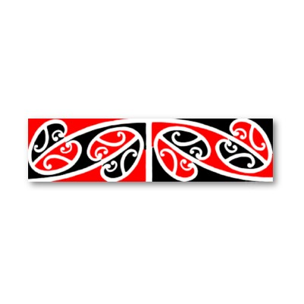

Colours – Ngā Tae

Red - whero
Orange - karaka
Yellow - kōwhai
Green - kākāriki
Blue - kahurangi
Purple - poroporo
White - mā

Brown - paraone

Black - pongo

