Blake Team ROOM 5 Homework Term 3 2015
This term students will have a list of activities from which they must choose two to complete each week. Once completed a brief record of each activity needs to be written into the homework book and returned to school on the following Thursday.
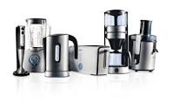
Students may choose to present their work as a recount, photo record, comic strip, flow chart, set of instructions, Venn diagram, labelled sketch, poster, powerpoint (which could be emailed). Spelling words will continue to be sent home each week, plus basic facts/number knowledge goal plus daily recreational reading.

If you wish your child to focus more on these activities then one activity from the list will suffice.

LIST OF POSSIBLE ACTIVITIES FOR YEAR 6 STUDENTS

- Use a simple kitchen appliance and explain how it works with diagrams.
- Use an atlas of New Zealand to find five places you have visited and explain what you did in each place.
- Use an old shopping docket from the supermarket and see if you can categorise the items bought into groups. Explain your groupings.
- Use an advertising brochure and pretend to buy some gifts for members of your family. Show how much you spent for each person and add up the total. Now choose something for yourself.
- Read your favourite childhood book and write a review about it.
- Make a toy or board game with an environmental theme.
- Ask a family member or visitor to explain to you what school was like when they were there. Present your findings in a Venn diagram.
- Go to the Pool and swim 8 lengths freestyle. Time yourself. Write about how you felt.
- Discuss a running route with your parents. Estimate how long it will take you, go out and do it, and see how close you were to your estimated time.
- Go for a nature walk in your garden or in a park. See how many things you can find beginning with b,g,d,t,m and f. Write about them when you get back.
- Can you find the answers to these – the largest ocean, the biggest continent, the largest lake in the world, the highest mountain, the deepest lake, the longest river, the highest waterfall, the longest mountain range and the deepest part of the ocean.
- Using pencils or paints experiment to see what colour combinations you can come up with e.g. red and white = pink
- Can you bake something delicious for your family to share. Ask an adult first.
- Learn how to play elastic twist. Explain some of the moves. Bring your elastic to share some ideas with the class
- Using a newspaper or property magazine find your ideal house for sale and explain why it would be good for you and your family.
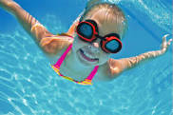
- Visit a Travel Agent and choose a location for a family holiday. Explain why this would be a good place for your family to visit.
- If you have ever been on an overseas trip recount some of the highlights. Remember to use good descriptive language.
- Ask Mum/Dad if you can organise the pantry tidily.
- Do a simple chore at home without being asked. Explain what you did.
- Change the sheets and make your own bed correctly. Record exactly what you did.
- Ask if you can hang the washing out one day. Explain what you had to do. Then make sure you bring it in and fold it neatly and put it away.
- Ask your parents if you could help vacuum some rooms of the house. Investigate how a vacuum cleaner works and include some sketches.
- Use a skipping rope and see if you can do 100 jumps without tripping. How many different steps can you invent? Explain them, give them a name and be prepared to show us some tricks.
- Watch the 6pm news one evening and record what the three main news items were. Write a brief summary of each one. Include some pictures.
- Use the TV Guide to choose one programme that you would like to watch each night of the week – explain why you made these choices.
- Unload the dishwasher without being asked and put the dishes carefully away. Explain how a dishwasher works.
- What is the difference between deciduous and evergreen trees? Do some research to explain your answer. Take some photos in your garden or surroundings to explain your findings.
- Offer to do a chore for an older person in your neighbourhood. Explain what you did.
- Design a passport for an alien from a different planet. Be as creative as possible.
- On a map of New Zealand plan a holiday for you and your family. Explain why you would like to visit each place.
- Cut out a newspaper article of current news and in your own words explain what has happened.
- Play a game of scrabble with a family member and see if you can make 4 six letter words. Take a photo of your finished game.
- Use a picture from a magazine as a seed for some writing. Write 5-6 lines of creative writing.
- Use a picture from a magazine as a seed for some poetry. Publish your poem as creatively as possible.
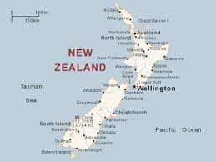
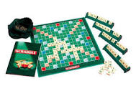

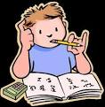
Week 1 Spelling List
1. 2.
3. 4.
5. 6.
7. 8.
9. 10.
11. 12
13. 14
15. 16.

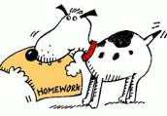
The basic facts or number knowledge goal I am practising this week is …..

This week I have been reading …..

Week 2 Spelling List
1. 2.
3. 4.
5. 6.
7. 8.
9. 10.
11. 12
13. 14
15. 16.

The basic facts or number knowledge goal I am practising this week is …..

This week I have been reading …..

Week 3 Spelling List
1. 2.
3. 4.
5. 6.
7. 8.
9. 10.
11. 12
13. 14
15. 16.

The basic facts or number knowledge goal I am practising this week is …..

This week I have been reading …..

Week 4 Spelling List
1. 2.
3. 4.
5. 6.
7. 8.
9. 10.
11. 12
13. 14
15. 16.

The basic facts or number knowledge goal I am practising this week is …..

This week I have been reading …..

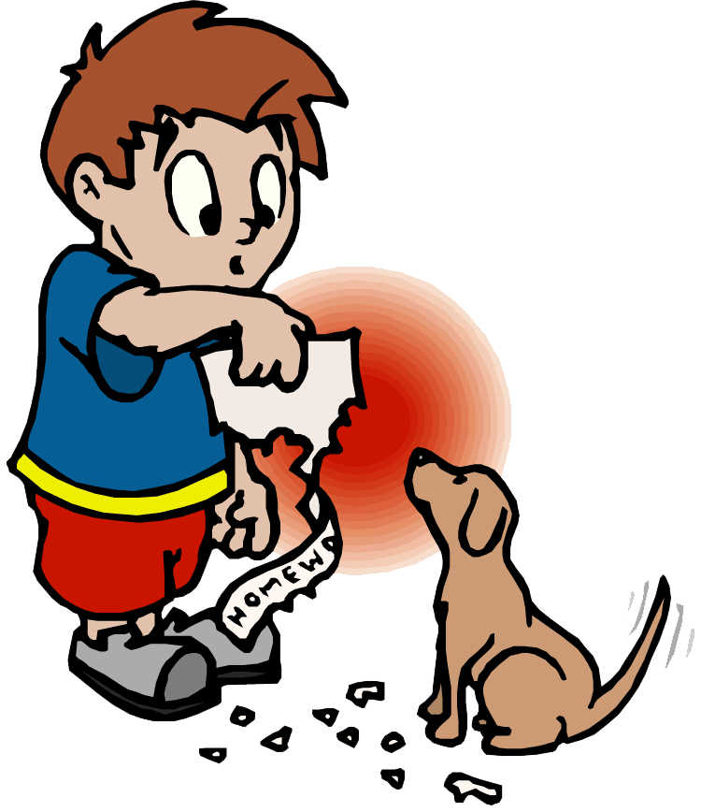

Week 5 Spelling List
1. 2.
3. 4.
5. 6.
7. 8.
9. 10.
11. 12
13. 14
15. 16.

The basic facts or number knowledge goal I am practising this week is …..

This week I have been reading …..

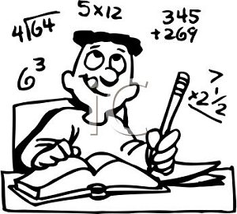
Week 6 Spelling List
1. 2.
3. 4.
5. 6.
7. 8.
9. 10.
11. 12
13. 14
15. 16.

The basic facts or number knowledge goal I am practising this week is …..

This week I have been reading …..

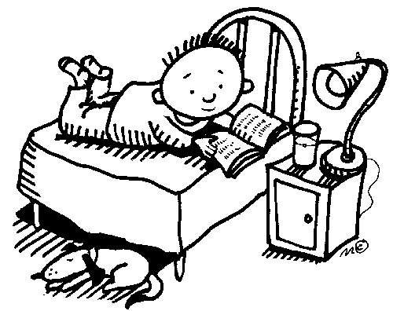

Week 7 Spelling List
1. 2.
3. 4.
5. 6.
7. 8.
9. 10.
11. 12
13. 14
15. 16.

The basic facts or number knowledge goal I am practising this week is …..

This week I have been reading …..

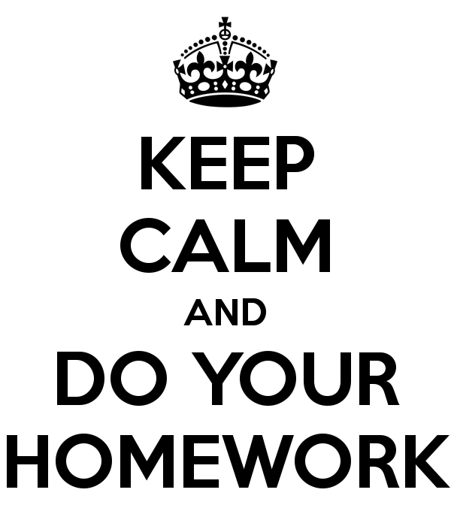
Week 8 Spelling List
1. 2.
3. 4.
5. 6.
7. 8.
9. 10.
11. 12
13. 14
15. 16.

The basic facts or number knowledge goal I am practising this week is …..

This week I have been reading …..

The basic facts or number knowledge goal I am practising this week is …..

This week I have been reading …..

