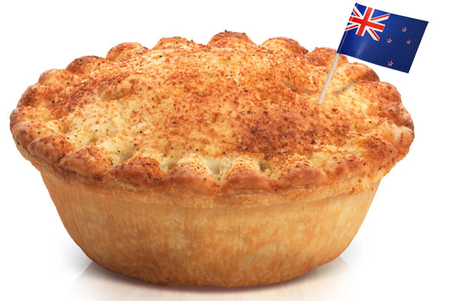
AUTHOR’S PURPOSE

The author wrote this for a reason. Remember “PIE”

Persuade  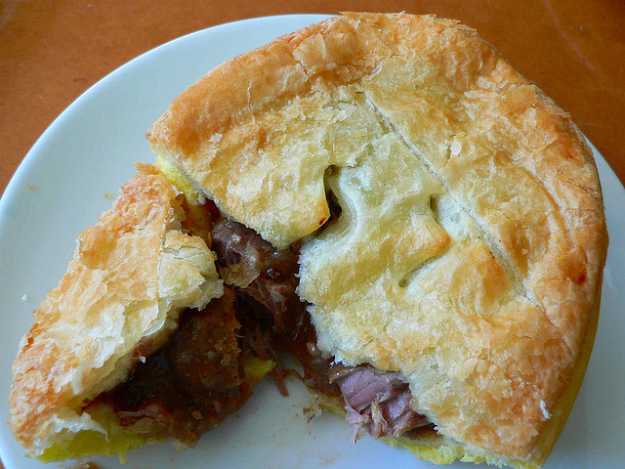 | Inform  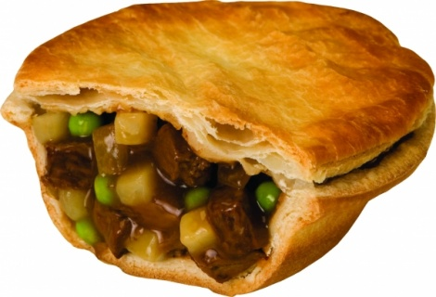 | Entertain  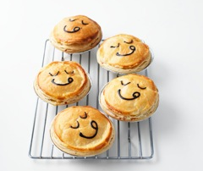
The author is trying to. | The author is trying to... | The author is trying to.
I know because … | I know because... | I know because
Examples: | Examples: | Examples:

