Literacy Tasks for Week 10 and 11 around Anzac Day

Make sure you put the heading of each activity in your reading book before completing it. Aim to complete at least 1 a day. Remember quality work!

Answering Questions:  Using the Journal Level 2 June 2014. Read the story on pages 8-15. Then answer the questions below in full sentences.  - What were the main issues/problems for soldiers?  - Why didn’t all the mascots come back to NZ?  - Why did quarantine rules prevent some from returning?  - What does the phrase ‘been through a lot’ mean?  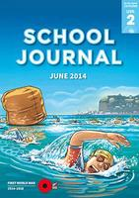 | Timeline  Read the SJ Level 3 June 2014 page 2 NZ At War. Construct your own timeline in your book choose 1-2 key events from each year to include. Make sure to write it in your own words.  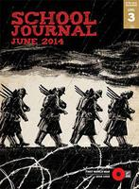 | Positives and Negatives  Read the Sj Level 3 June 2014 on page 32 called ‘Grey Angels’. Write down 2 positives and 3 different negatives for the woman that were nurses in the war. Make sure to write full sentences.
Summary  Using the SJ Part 2 Number 1 2006 read the story on page 15 “Pigeon Post’. Write a summary in your book about how pigeons were used in the war. | Reading for enjoyment  Read the SJ Part 3 Number 2 1998 on page 2 called ‘War Games’. While you are reading create a picture in your head about what it would have been like for these children. | Extra for Experts  Read the SJ Part 4 Number 3 2008 on page 2. Write 5 sentences about what you have learnt about world war 1 by reading this story.
Vocabulary  Look up these words in a dictionary or on your device write your own definitions in your book.  Commemoration  Honour  British Empire  Cenotaph  Armistice  Veteran | Listen to Reading  Listen to the story Anzac Ted  Click Here  Listen to Online Anzac story  Click Here  Listen to the story Dawn Parade  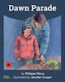Click Here | Tonga  Using the Sj Part 3 Num 1 2009 read the story on page 18 ‘Spitfires from Tonga’. Write in your own words about how Tonga helped in World War 2.

