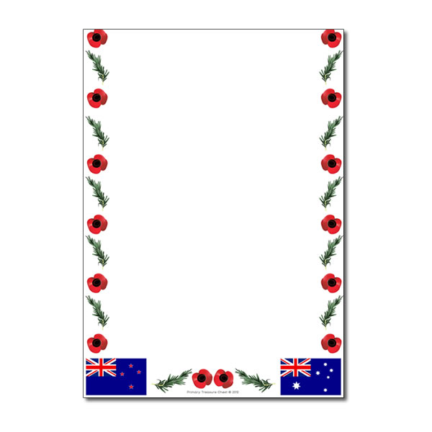

Anzac

I wear a little poppy,

As red as red can be,

To show that I respect and remember,

Those brave men who fought

to make New Zealand free.

