LEST WE FORGET
Judi Billcliff

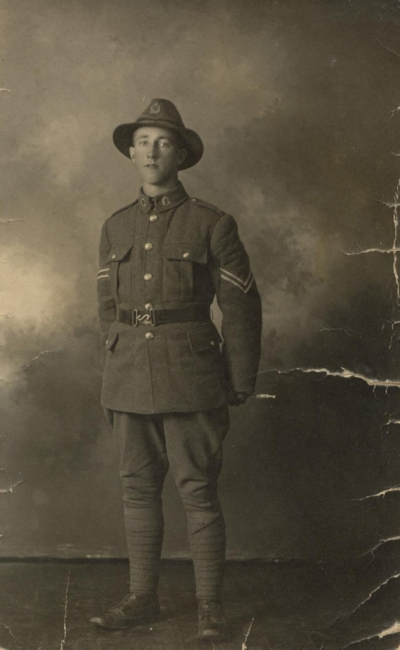
Great Grandfather was a soldier
Who went to fight at war.
He said he saw horrific sights
He’d never seen before.

When he climbed aboard the ship
And headed out to sea,
It was like a big adventure,
Not a piece of history.

Young men with not a worry
As if it was a game.
But it only took one bullet
To remind them why they came.

Some fought the battle out at sea
Some fought it on the land
In the mud encrusted trenches
Trying to make a stand.

With enemy fire overhead
Their comrades falling down.
Trying to muster all their strength
To keep moving on the ground.

Trying to win each battle
And eventually win the war
Was the overriding thought within -
Frightened to wish for more

Like being home with their families
Which seemed so far away.
A letter here, a letter there
Was what got them through each day.

But when I look around the world
Wars are still being fought.
It seems the saying, ‘ Lest We Forget,’
Is no longer being taught.

© Rainbow Poetry 2014 J Billcliff www.rainbowpoetry.co.nz
Lest We Forget

SUGGESTED ACTIVITIES

Language
- Underline the words in the second verse that tell you how the young men felt when they boarded the ship.
- Underline the words in the third verse that make the young men realise it wasn’t a game
- Make a list of the words you don’t know in the poem. Discuss in pairs what they might mean.
- Why did these young soldiers travel to war by ship?
- What does the word ‘comrades’ mean?
- What does the word ‘muster’ mean?
- Write a sentence with the word muster in it.
- What do you think it would be like for the families
left at home during war?

- Imagine you have been separated from your family. Discuss first why you might have been separated.
Now write a letter home telling them what’s happened.
- Get into groups of 4, and read the letters to one another. Then choose one to act out.
- Make a list of what important items you would need if there was an emergency. e.g a power cut
- Act out a short scene about an emergency. Do the scene as a series of still slides.
- Repeat the scene again but this time adding words.

Drama Based

- Invite a refugee or an elderly person who has lived through war, into the classroom, to share their story.
There might be a refugee family attending your school.
- What is The Last Post?
- Which of the following countries are not in Europe?
Belgium Germany India France
- Have a group/class discussion:
What are we remembering on ANZAC day?
Why do we buy red poppies in April?

Extension Work

- Think about why you are separated from your family.
- How long since your family had heard from you?
- Be aware of the changing moods in the poem.
- Remember to speak one at a time when acting out scenes.

Performance

© Rainbow Poetry 2014 Judi Billcliff adapted from ‘Poetry Rocks’ teacher resource

