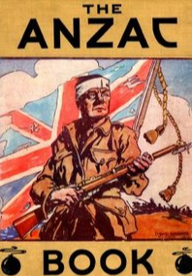

Australia and New Zealand:
the ANZAC connection

To most New Zealanders and Australians, ANZAC Day is a very special day in the year.

The letters stand for Australian and New Zealand Army Corps.

Here is a map of the world so that you can see that Australia is not very far away from New Zealand.

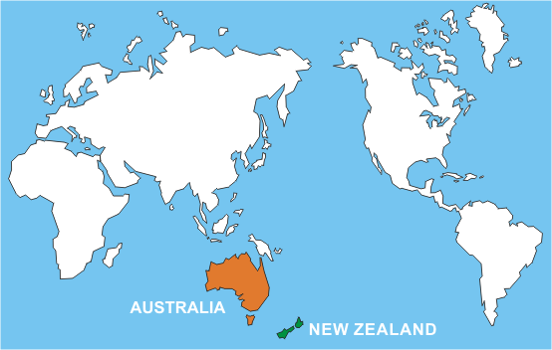
Because our countries are so close we stay friends with Australia so that we can help each other if we have to, particularly in times of war because the rest of the world is so far away.

Australia looks like this: New Zealand looks like this:
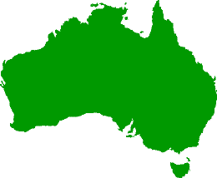 | 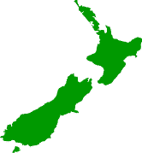
Each country has its own flag.

The Australian Flag looks like this:  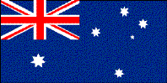 | The New Zealand Flag looks like this:  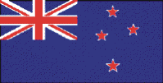
Can you see the difference?
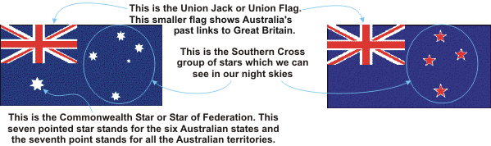
Sometimes Australians are called Aussies. Australian soldiers are called Diggers.

New Zealanders are called Kiwis after our native bird.

Australian and New Zealand soldiers came from different places, homes and cultures -- some were teenage boys, others were fathers with young children. Some soldiers lived in cities and towns and some lived on small islands.

War

A long time ago there was a war. A war is like a big fight between countries who disagree over some things.

Most of the countries in the world joined in the fighting and this was called the First World War. This war lasted four years. There was a second World War which lasted for six years. Since then there have been other small wars and battles like in Vietnam.

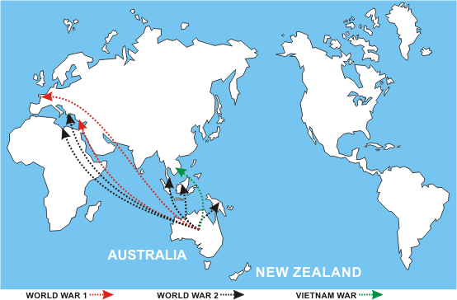
The dotted lines show where New Zealanders travelled to in some of the conflicts of the 20th century.

To be at war is not a good thing because people can get hurt or killed and lose their possessions (eg, home, car, toys, dogs, cats or even their family members) and this makes people very sad.

Very brave people are called heroes. Simpson and his donkey are famous heroes from the First World War. Simpson put wounded soldiers on the donkey’s back and helped them to the first aid tent.
Defence Forces

Most countries have people who work in the army, the navy or the air force -- this is called the Defence Force.

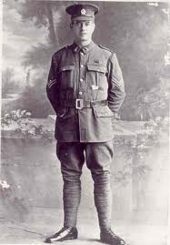
Some of the uniforms people wore in the First World War looked like this ->

“Defend” means “to keep safe” and the people in the Australian Defence Force keep our country safe and protect us.
The soldiers make up the Army and defend and fight on the ground.

The sailors mostly fight and defend from their ships and submarines at sea and on the oceans.

The air force people fight and defend in their planes in the air.

There are also special nurses who look after the wounded.

The people in the Army, Navy and Air Force wear special uniforms which help to identify the part of the Defence Force to which they belong. Today the uniforms look like this:
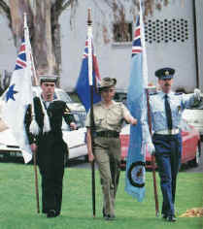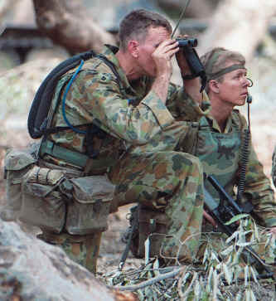
New Zealand has sent soldiers, sailors, airmen and nurses to other countries (like Timor, Solomon Islands and Iraq) when they needed help, as well as looked after our country. When they go to countries to help to keep the peace, these Defence people from New Zealand (and other countries) are known as 'peacekeepers'.

Within the Defence Force there are men and women who are doctors, dentists, cooks, musicians, truck drivers etc.

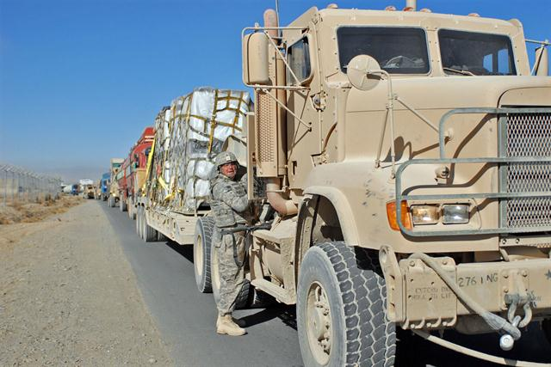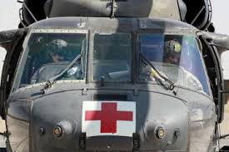

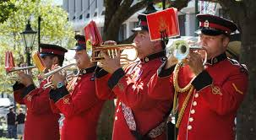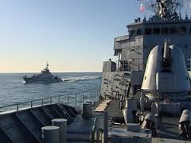

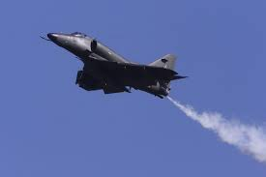

ANZAC Day

On ANZAC Day, 25th April each year, we remember the brave men and women who have served our country in times of war.

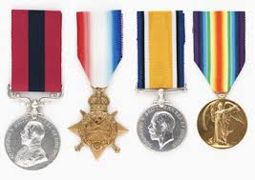
People who have defended our country get special medals. These medals are proudly worn on ANZAC Day when we especially remember all the people who have died or suffered in wars so that we might live freely.

Some of the medals look like this ->

To be free means that we can do things like go where we want to go, live where we want to live, own our own things, have food to eat,
a job to earn money and act as we want to act.

In some countries people are not allowed to do these things.

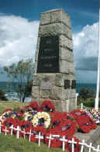
On ANZAC Day we show our thanks to the people who have fought for our country. It is such a special day it has been made a holiday so families can go to the march in their towns.

We can wear ANZAC badges and wave New Zealand flags to show how proud we are.

This is a special memorial called a cenotaph where people lay wreaths to remember the people who have died in wars.

The Ode is part of a special poem that is said during the ANZAC Day service. Here are the words:

They shall grow not old, as we that are left grow old;
Age shall not weary them, nor the years condemn.
At the going down of the sun and in the morning
We will remember them.

The Last Post is sounded on a bugle on ANZAC Day to remind us of the many soldiers killed or hurt during wars.

On ANZAC Day flowers and wreaths of red poppies are laid at the bottom of war memorials as a way of saying we have remembered these brave people. A war memorial is a place that honours all those who have died in wars.

On other special days in the year, like Remembrance Day, at 11am on the 11th day of the 11th month (November) we also remember those people who have fought for our country. On Remembrance Day, Australia, and many other countries, celebrate the end of World War 1. Those countries that were at war signed an important piece of paper on that day to say that they would no longer fight.

We should never forget these brave New Zealanders.

Isn’t it great to be a Kiwi?

