Rua tekau ma tahi (2x10) + 21

Rua tekau ma rua (2x10) + 22
_______________________________________________

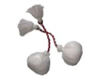
toru tekau 3x 30

wha tekau 4x 40

rima tekau 5x 50

ono tekau 6x 60

whitu tekau 7x 70

waru tekau 8x 80

iwa tekau 9x 9090

kotahi rua 10x 10100

