Writing Planning/Evaluation | Group | Term ___Week ___
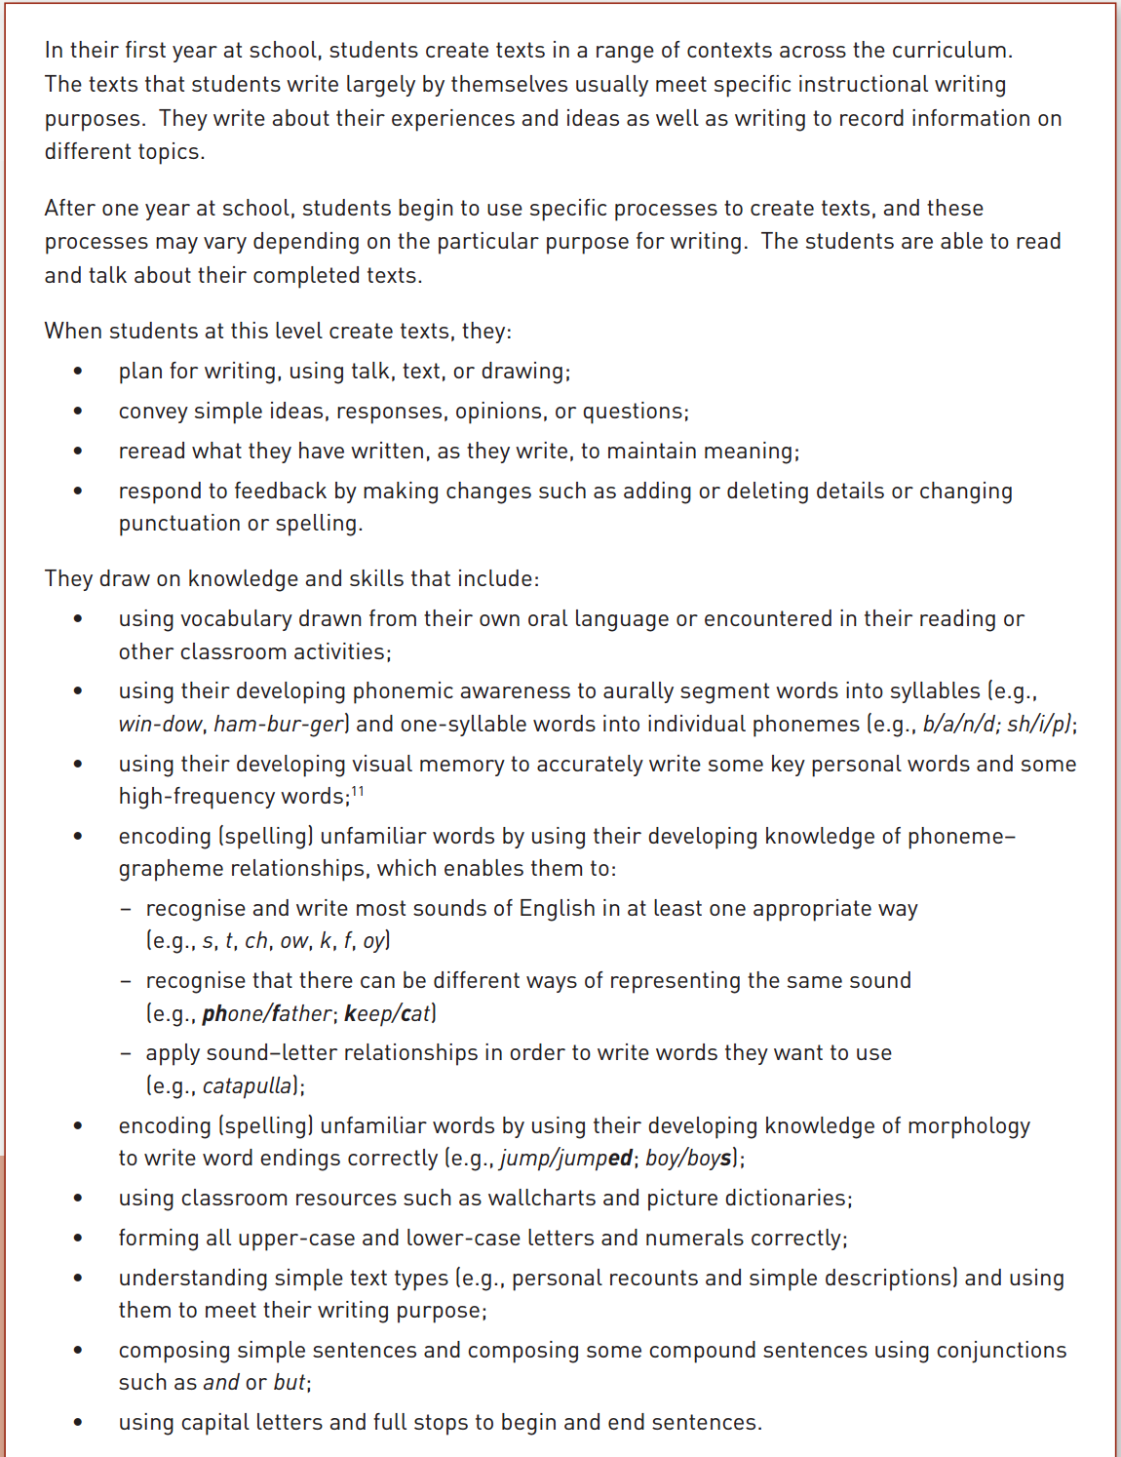 | Name | Name
 | Name | Name
 | Name | Name

