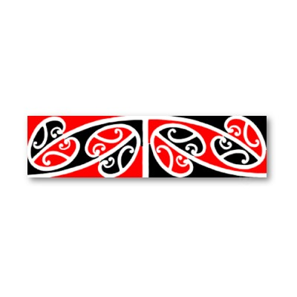

**tahi [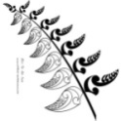](http://www.bing.com/images/search?q=maori+pictures&view=detail&id=E8B3682D52494685076B0DE5D12F764A03AF8B26&first=31&qpvt=maori+pictures&FORM=IDFRIR) 1**

**rua [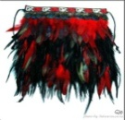](http://www.bing.com/images/search?q=maori+pictures&view=detail&id=B19CB9F65E99B1C1371DD1EDE357D60042191C79&first=0&qpvt=maori+pictures&FORM=IDFRIR) 2**

**toru [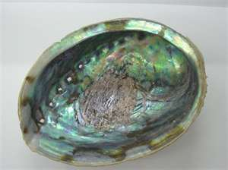](http://www.bing.com/images/search?q=paua+shell+pictures&view=detail&id=4FEE4CDDA3434A28195A97D1B36EB7B9F52B6D96&first=0&qpvt=paua+shell+pictures&FORM=IDFRIR) 3**

**wha** [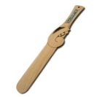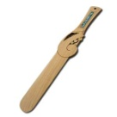](http://www.bing.com/images/search?q=paua+shell+pictures&view=detail&id=80DB9AA54FDB11FF90E733BE861E7269CDA2A6C2&first=31&qpvt=paua+shell+pictures&FORM=IDFRIR) **4**

**rima** [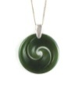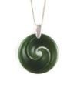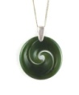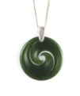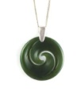](http://www.bing.com/images/search?q=koru+patterns&view=detail&id=9EA752208274576C5562B1DFB011FDF7912ACE52&first=61&qpvt=koru+patterns&FORM=IDFRIR) **5**

**ono** [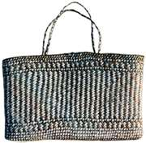](http://www.bing.com/images/search?q=maori+weaving&view=detail&id=8D073209C2A576D0406558D5E6E6975F076F9A93&first=31&qpvt=maori+weaving&FORM=IDFRIR) **6**

**whitu** [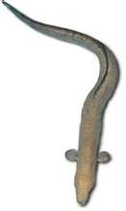](http://www.bing.com/images/search?q=maori+eel+pictures&view=detail&id=E468198C78DB8F181D46640EA93B635E1AC0EAD8&first=0&qpvt=maori+eel+pictures&FORM=IDFRIR) **7**

**waru** [](http://www.bing.com/images/search?q=Maori+flag&view=detail&id=44B40C42604AF002CE5AB64EA5FB2C90A57625F5&first=0&qpvt=Maori+flag&FORM=IDFRIR) [](http://www.bing.com/images/search?q=Maori+flag&view=detail&id=44B40C42604AF002CE5AB64EA5FB2C90A57625F5&first=0&qpvt=Maori+flag&FORM=IDFRIR) [](http://www.bing.com/images/search?q=Maori+flag&view=detail&id=44B40C42604AF002CE5AB64EA5FB2C90A57625F5&first=0&qpvt=Maori+flag&FORM=IDFRIR) [](http://www.bing.com/images/search?q=Maori+flag&view=detail&id=44B40C42604AF002CE5AB64EA5FB2C90A57625F5&first=0&qpvt=Maori+flag&FORM=IDFRIR) **8**

[](http://www.bing.com/images/search?q=Maori+flag&view=detail&id=44B40C42604AF002CE5AB64EA5FB2C90A57625F5&first=0&qpvt=Maori+flag&FORM=IDFRIR) [](http://www.bing.com/images/search?q=Maori+flag&view=detail&id=44B40C42604AF002CE5AB64EA5FB2C90A57625F5&first=0&qpvt=Maori+flag&FORM=IDFRIR) [](http://www.bing.com/images/search?q=Maori+flag&view=detail&id=44B40C42604AF002CE5AB64EA5FB2C90A57625F5&first=0&qpvt=Maori+flag&FORM=IDFRIR) [](http://www.bing.com/images/search?q=Maori+flag&view=detail&id=44B40C42604AF002CE5AB64EA5FB2C90A57625F5&first=0&qpvt=Maori+flag&FORM=IDFRIR)

**iwa [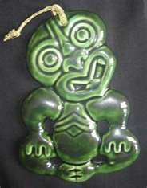](http://www.bing.com/images/search?q=Maori+tiki+pictures&view=detail&id=2BDBF3FDAC00A11F47DFD859E57C24643CC93ED7&first=31&qpvt=Maori+tiki+pictures&FORM=IDFRIR) [](http://www.bing.com/images/search?q=Maori+tiki+pictures&view=detail&id=2BDBF3FDAC00A11F47DFD859E57C24643CC93ED7&first=31&qpvt=Maori+tiki+pictures&FORM=IDFRIR) [](http://www.bing.com/images/search?q=Maori+tiki+pictures&view=detail&id=2BDBF3FDAC00A11F47DFD859E57C24643CC93ED7&first=31&qpvt=Maori+tiki+pictures&FORM=IDFRIR) [](http://www.bing.com/images/search?q=Maori+tiki+pictures&view=detail&id=2BDBF3FDAC00A11F47DFD859E57C24643CC93ED7&first=31&qpvt=Maori+tiki+pictures&FORM=IDFRIR) [](http://www.bing.com/images/search?q=Maori+tiki+pictures&view=detail&id=2BDBF3FDAC00A11F47DFD859E57C24643CC93ED7&first=31&qpvt=Maori+tiki+pictures&FORM=IDFRIR) 9**

**[](http://www.bing.com/images/search?q=Maori+tiki+pictures&view=detail&id=2BDBF3FDAC00A11F47DFD859E57C24643CC93ED7&first=31&qpvt=Maori+tiki+pictures&FORM=IDFRIR) [](http://www.bing.com/images/search?q=Maori+tiki+pictures&view=detail&id=2BDBF3FDAC00A11F47DFD859E57C24643CC93ED7&first=31&qpvt=Maori+tiki+pictures&FORM=IDFRIR) [](http://www.bing.com/images/search?q=Maori+tiki+pictures&view=detail&id=2BDBF3FDAC00A11F47DFD859E57C24643CC93ED7&first=31&qpvt=Maori+tiki+pictures&FORM=IDFRIR) [](http://www.bing.com/images/search?q=Maori+tiki+pictures&view=detail&id=2BDBF3FDAC00A11F47DFD859E57C24643CC93ED7&first=31&qpvt=Maori+tiki+pictures&FORM=IDFRIR)**

**tekau [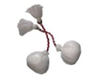](http://www.bing.com/images/search?q=poi+pictures&view=detail&id=8AAEB750A676324F9CEFFB2ED283C8838DAB1EE9&first=0&qpvt=poi+pictures&FORM=IDFRIR) 10**

