

**tekau ma tahi 10+ [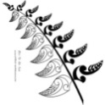](http://www.bing.com/images/search?q=maori+pictures&view=detail&id=E8B3682D52494685076B0DE5D12F764A03AF8B26&first=31&qpvt=maori+pictures&FORM=IDFRIR) 11**

**tekau ma rua 10+ [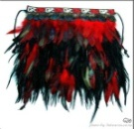](http://www.bing.com/images/search?q=maori+pictures&view=detail&id=B19CB9F65E99B1C1371DD1EDE357D60042191C79&first=0&qpvt=maori+pictures&FORM=IDFRIR) 12**

**tekau ma toru 10+ [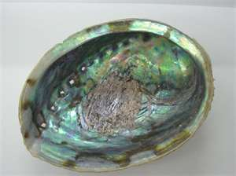](http://www.bing.com/images/search?q=paua+shell+pictures&view=detail&id=4FEE4CDDA3434A28195A97D1B36EB7B9F52B6D96&first=0&qpvt=paua+shell+pictures&FORM=IDFRIR) 13**

**tekau ma wha 10+** [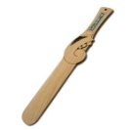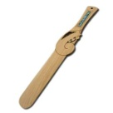](http://www.bing.com/images/search?q=paua+shell+pictures&view=detail&id=80DB9AA54FDB11FF90E733BE861E7269CDA2A6C2&first=31&qpvt=paua+shell+pictures&FORM=IDFRIR) **14**

**tekau ma rima 10+** [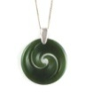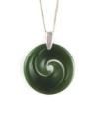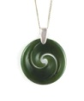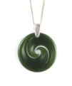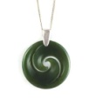](http://www.bing.com/images/search?q=koru+patterns&view=detail&id=9EA752208274576C5562B1DFB011FDF7912ACE52&first=61&qpvt=koru+patterns&FORM=IDFRIR) **15**

**tekau ma ono 10+** [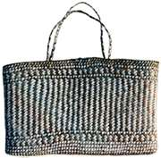](http://www.bing.com/images/search?q=maori+weaving&view=detail&id=8D073209C2A576D0406558D5E6E6975F076F9A93&first=31&qpvt=maori+weaving&FORM=IDFRIR) **16**

**tekau ma whitu 10+** [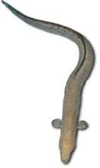](http://www.bing.com/images/search?q=maori+eel+pictures&view=detail&id=E468198C78DB8F181D46640EA93B635E1AC0EAD8&first=0&qpvt=maori+eel+pictures&FORM=IDFRIR) **17**

**tekau ma waru 10+** [](http://www.bing.com/images/search?q=Maori+flag&view=detail&id=44B40C42604AF002CE5AB64EA5FB2C90A57625F5&first=0&qpvt=Maori+flag&FORM=IDFRIR) [](http://www.bing.com/images/search?q=Maori+flag&view=detail&id=44B40C42604AF002CE5AB64EA5FB2C90A57625F5&first=0&qpvt=Maori+flag&FORM=IDFRIR) [](http://www.bing.com/images/search?q=Maori+flag&view=detail&id=44B40C42604AF002CE5AB64EA5FB2C90A57625F5&first=0&qpvt=Maori+flag&FORM=IDFRIR) [](http://www.bing.com/images/search?q=Maori+flag&view=detail&id=44B40C42604AF002CE5AB64EA5FB2C90A57625F5&first=0&qpvt=Maori+flag&FORM=IDFRIR) **18**

[](http://www.bing.com/images/search?q=Maori+flag&view=detail&id=44B40C42604AF002CE5AB64EA5FB2C90A57625F5&first=0&qpvt=Maori+flag&FORM=IDFRIR) [](http://www.bing.com/images/search?q=Maori+flag&view=detail&id=44B40C42604AF002CE5AB64EA5FB2C90A57625F5&first=0&qpvt=Maori+flag&FORM=IDFRIR) [](http://www.bing.com/images/search?q=Maori+flag&view=detail&id=44B40C42604AF002CE5AB64EA5FB2C90A57625F5&first=0&qpvt=Maori+flag&FORM=IDFRIR) [](http://www.bing.com/images/search?q=Maori+flag&view=detail&id=44B40C42604AF002CE5AB64EA5FB2C90A57625F5&first=0&qpvt=Maori+flag&FORM=IDFRIR)

**tekau ma iwa 10+[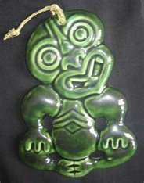](http://www.bing.com/images/search?q=Maori+tiki+pictures&view=detail&id=2BDBF3FDAC00A11F47DFD859E57C24643CC93ED7&first=31&qpvt=Maori+tiki+pictures&FORM=IDFRIR) [](http://www.bing.com/images/search?q=Maori+tiki+pictures&view=detail&id=2BDBF3FDAC00A11F47DFD859E57C24643CC93ED7&first=31&qpvt=Maori+tiki+pictures&FORM=IDFRIR) [](http://www.bing.com/images/search?q=Maori+tiki+pictures&view=detail&id=2BDBF3FDAC00A11F47DFD859E57C24643CC93ED7&first=31&qpvt=Maori+tiki+pictures&FORM=IDFRIR) [](http://www.bing.com/images/search?q=Maori+tiki+pictures&view=detail&id=2BDBF3FDAC00A11F47DFD859E57C24643CC93ED7&first=31&qpvt=Maori+tiki+pictures&FORM=IDFRIR) [](http://www.bing.com/images/search?q=Maori+tiki+pictures&view=detail&id=2BDBF3FDAC00A11F47DFD859E57C24643CC93ED7&first=31&qpvt=Maori+tiki+pictures&FORM=IDFRIR) 19**

**[](http://www.bing.com/images/search?q=Maori+tiki+pictures&view=detail&id=2BDBF3FDAC00A11F47DFD859E57C24643CC93ED7&first=31&qpvt=Maori+tiki+pictures&FORM=IDFRIR) [](http://www.bing.com/images/search?q=Maori+tiki+pictures&view=detail&id=2BDBF3FDAC00A11F47DFD859E57C24643CC93ED7&first=31&qpvt=Maori+tiki+pictures&FORM=IDFRIR) [](http://www.bing.com/images/search?q=Maori+tiki+pictures&view=detail&id=2BDBF3FDAC00A11F47DFD859E57C24643CC93ED7&first=31&qpvt=Maori+tiki+pictures&FORM=IDFRIR) [](http://www.bing.com/images/search?q=Maori+tiki+pictures&view=detail&id=2BDBF3FDAC00A11F47DFD859E57C24643CC93ED7&first=31&qpvt=Maori+tiki+pictures&FORM=IDFRIR)**

**rua tekau 2x [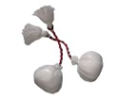](http://www.bing.com/images/search?q=poi+pictures&view=detail&id=8AAEB750A676324F9CEFFB2ED283C8838DAB1EE9&first=0&qpvt=poi+pictures&FORM=IDFRIR) 20**

